Semester One Examination, 2021

Question/Answer booklet

MATHEMATICS SPECIALIST
UNIT 3

Section Two:

Calculator-assumed

Your Name

Your Teacher’s Name

Time allowed for this section
Reading time before commencing work: ten minutes
Working time: one hundred minutes

Materials required/recommended for this section
To be provided by the supervisor
This Question/Answer booklet
Formula sheet (retained from Section One)

To be provided by the candidate
Standard items: pens (blue/black preferred), pencils (including coloured), sharpener, correction fluid/tape, eraser, ruler, highlighters

Special items: drawing instruments, templates, notes on two unfolded sheets of A4 paper, and up to three calculators approved for use in this examination

Important note to candidates
No other items may be taken into the examination room. It is your responsibility to ensure that you do not have any unauthorised material. If you have any unauthorised material with you, hand it to the supervisor before reading any further.
Question | Marks | Max | Question | Marks | Max
9 |  |  | 16
10 |  |  | 17
11 |  |  | 18
12 |  |  | 19
13 |  |  | 20
14 |  |  | 21
15 |  |  | 22

Structure of this paper

Section | Number of questions available | Number of questions to be answered | Working time (minutes) | Marks available | Percentage of examination
Section One:  Calculator-free | 8 | 8 | 50 | 49 | 34
Section Two:  Calculator-assumed | 14 | 14 | 100 | 96 | 66
 |  |  |  | Total | 100

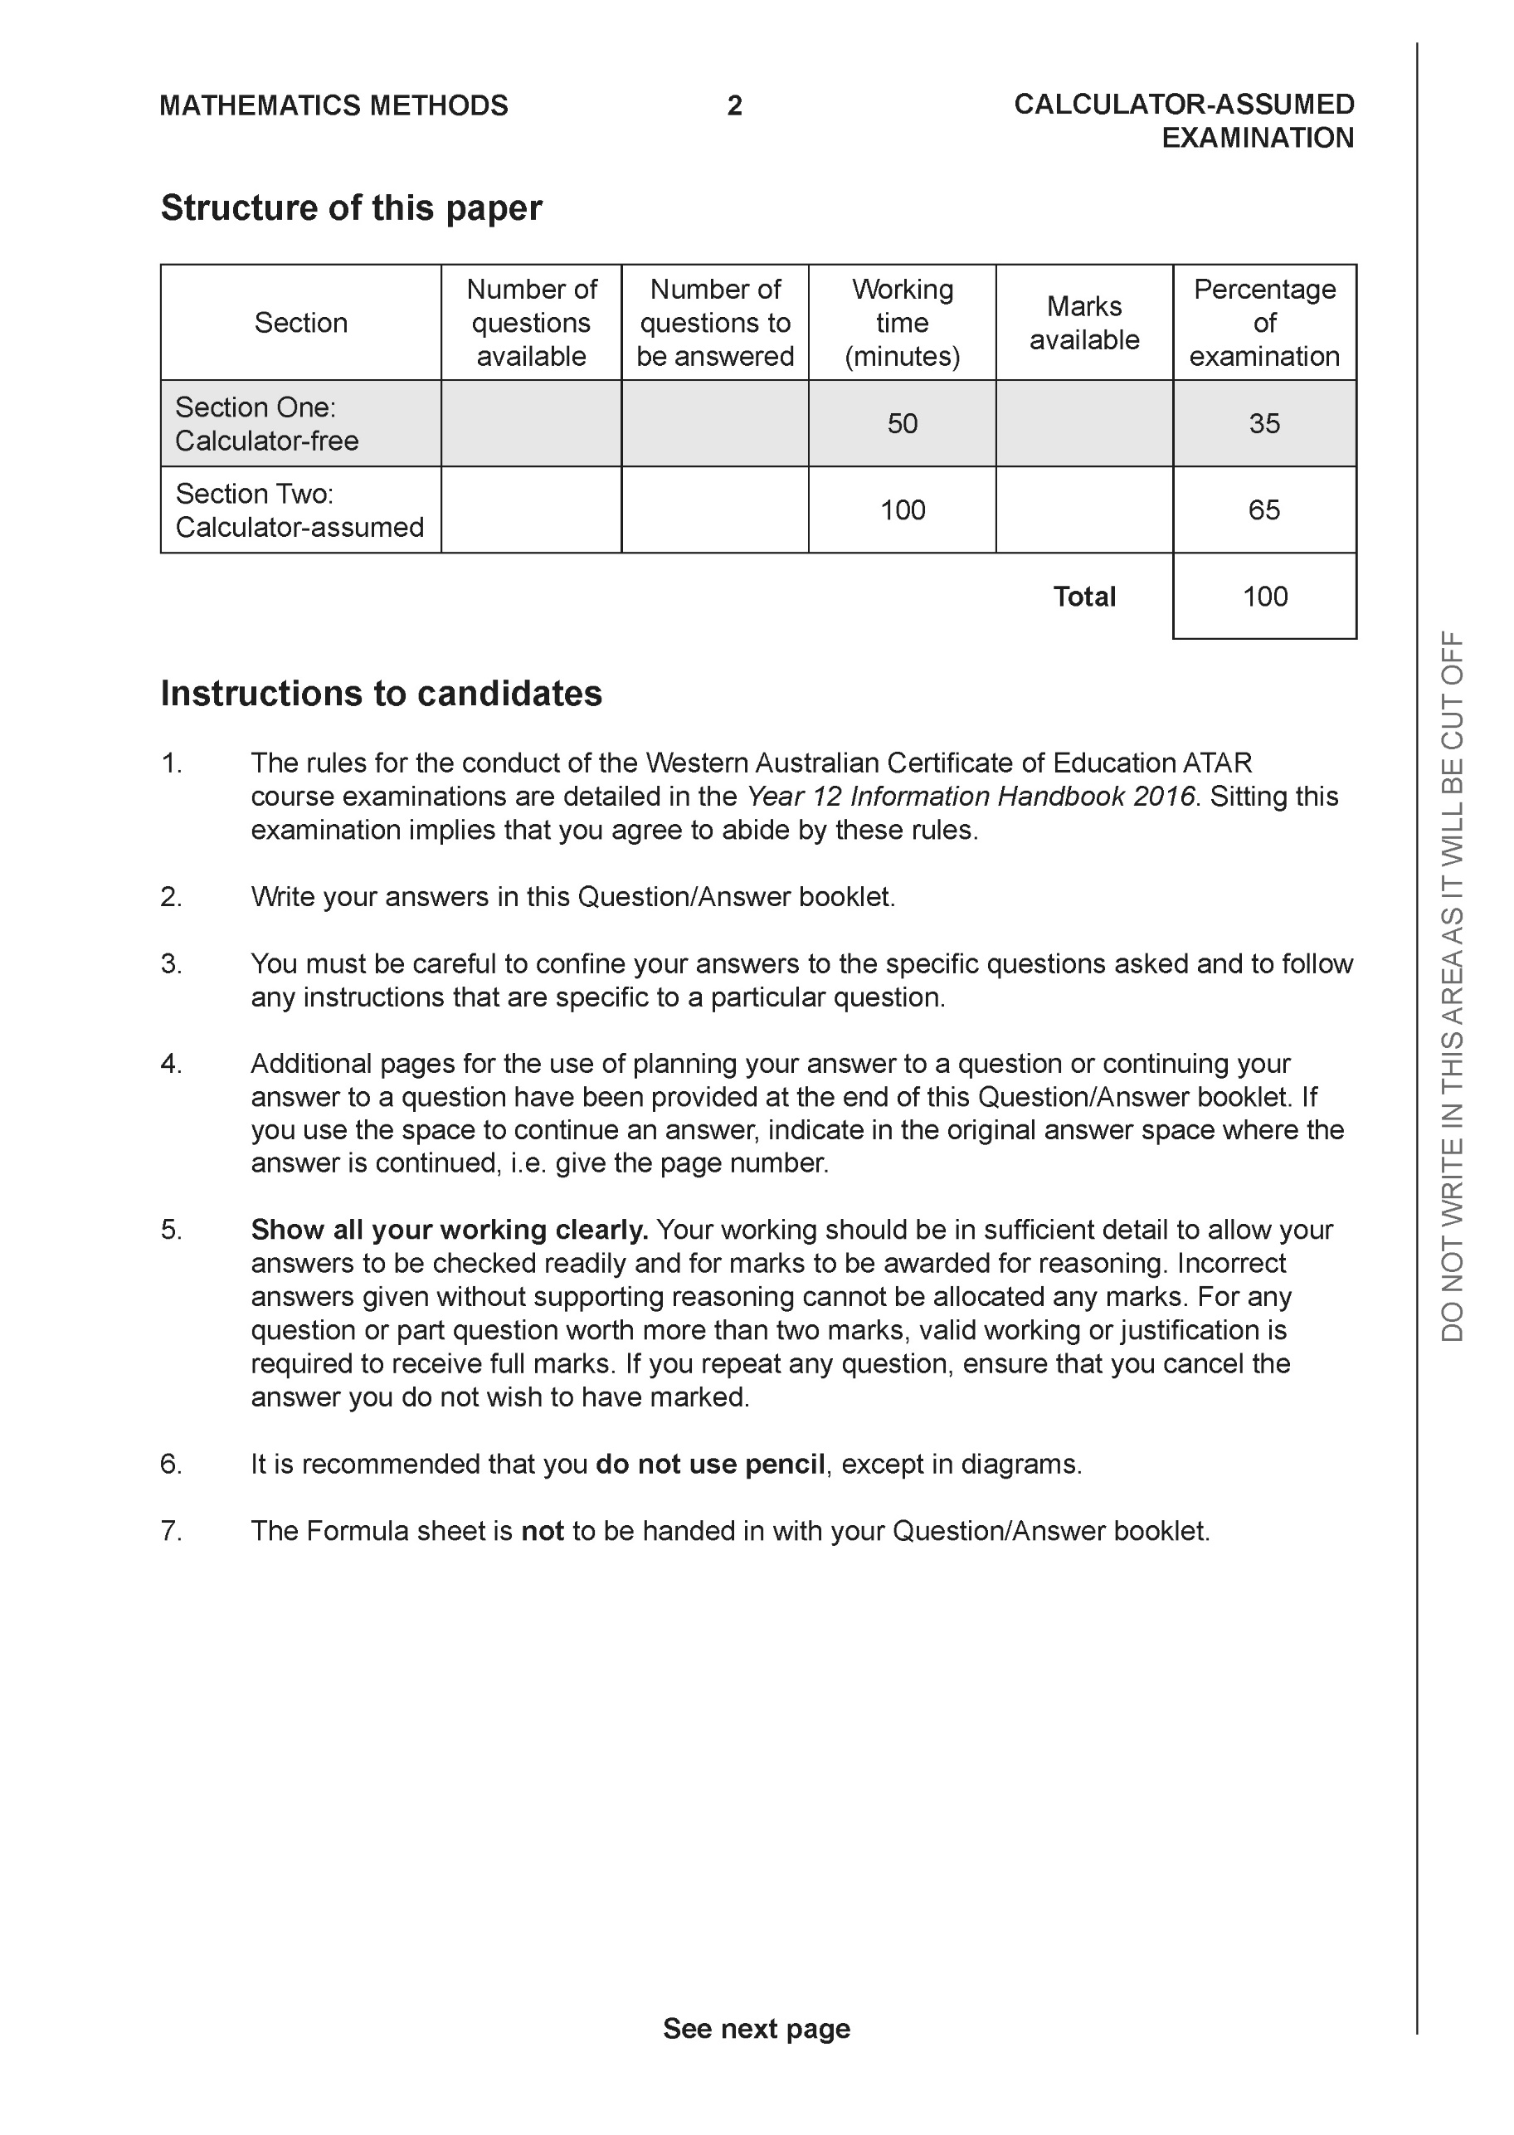

Section Two: Calculator-assumed (96 Marks)

This section has 14 questions. Answer all questions. Write your answers in the spaces provided.

Spare pages are included at the end of this booklet. They can be used for planning your responses and/or as additional space if required to continue an answer.
● Planning: If you use the spare pages for planning, indicate this clearly at the top of the page.
● Continuing an answer: If you need to use the space to continue an answer, indicate in the original answer space where the answer is continued, i.e. give the page number. Fill in the number of the question that you are continuing to answer at the top of the page.

Working time: 100 minutes.

Question 9 (6 marks)

- Sketch the locus of the equation on the axes below. (3 marks)

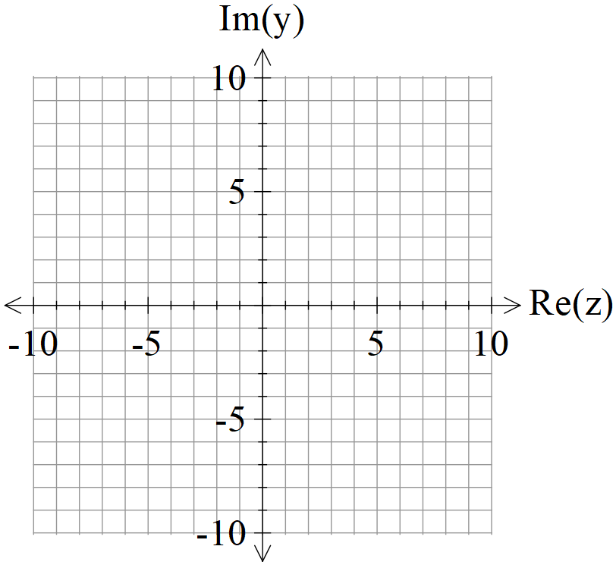

- Determine the cartesian equation of this locus in terms of . (3 marks)

Question 10 (9 marks)

Consider the locus as graphed below.
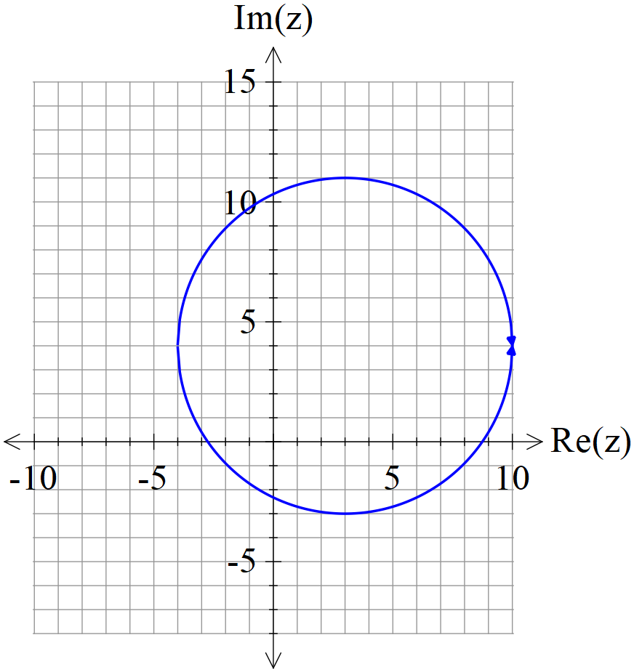

Determine the following.
- Maximum value of . (2 marks)

- Minimum value of (3 marks)

- Sketch the region defined by and on the axes above stating the coordinates of all boundary points. (4 marks)

Question 11 (6 marks)

Consider the line and the point A.
- Using scalar dot product show how to find the closest distance of point A to the line above.
(3 marks)

- Using vector cross product show how to find the closest distance of point A to the line above.
(3 marks)

Question 12 (9 marks)

Consider the sphere with being a positive constant and the line .

Determine all possible values of ,(2 decimal places) for the following.
- The line does not meet the sphere at all.
- The line just touches the sphere at one point only.
- The line meets the sphere at two points.

Question 13 (4 marks)

Consider a prism where each side is a parallelogram with opposites sides congruent.
The units given are in metres.

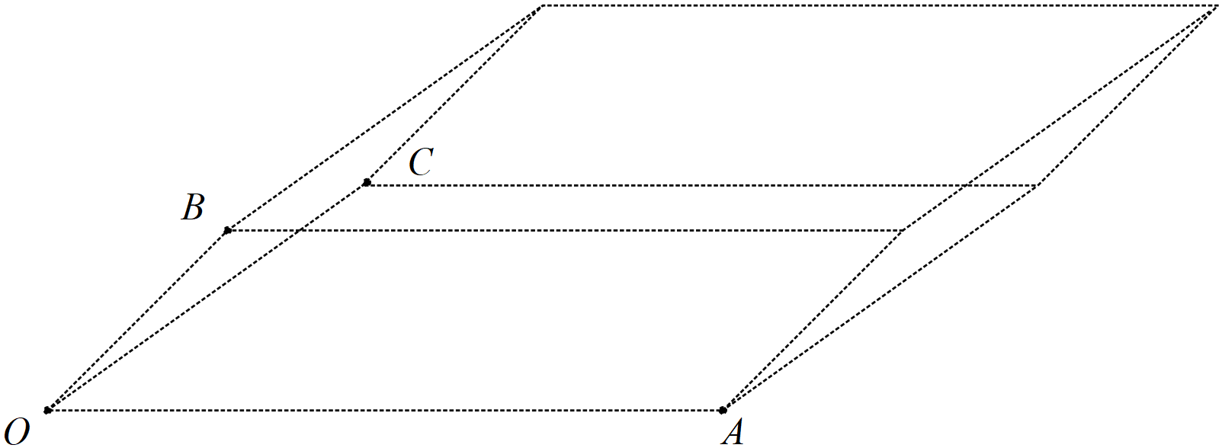

Given that and using vector methods, determine the volume of the prism. (Hint: Volume = area of face multiplied by perpendicular width)

Question 14 (9 marks)

Consider the plane .

- Determine the distance of point A from the plane . (4 marks)

- Determine an expression in terms of for the distance of point P from the plane . (3 marks)

- If point Ais on a plane parallel to , determine a vector equation for this parallel plane. (2 marks)

Question 15 (7 marks)

Consider two submarines A & B moving in deep ocean with constant velocities .
At 12:30am submarine A is at position and at 1am the same day
submarine B is at position .

- Determine the time of day, to nearest minute, that the submarines are closest to each other stating this distance to the nearest metre, (4 marks)

- If both submarines leave a lasting water trail of bubbles, determine if the trails cross and if they do at which position under water. (3 marks)

Question 16 (5 marks)

Consider the complex numbers such that:

Determine in the form where are real numbers.

Question 17 (11 marks)

Consider the 3D object as drawn below with the origin and

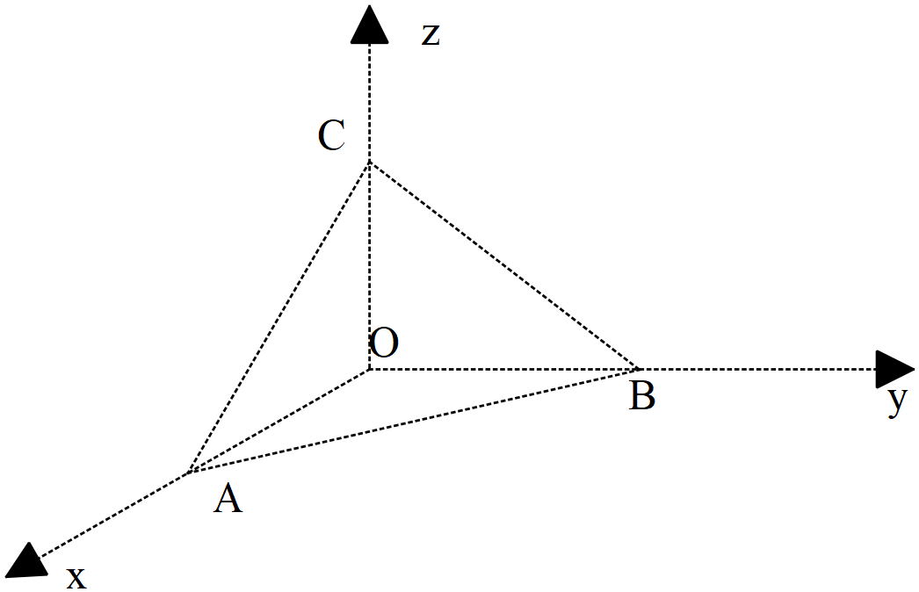
- Determine the vectors . (2 marks)

- Determine to the nearest degree the angle (2 marks)

- Determine the exact area of triangle using vectors. (3 marks)

- Determine the cartesian equation of the plane containing triangle . (4 marks)

Question 18 (7 marks)

Consider the vectors
- Determine given that are parallel, is perpendicular to and is perpendicular to . (4 marks)

- Given that , determine a vector parallel to but equal in magnitude to .
(3 marks)

Question 19 (7 marks)

- Consider the cartesian equation . Describe what this locus of points represents and state major features and give the vector equation.
(4 marks)

- Consider the equation where is a constant. Determine the values of for which the equation would be a sphere giving the centre and radius in terms of . (3 marks)

Question 20 (6 marks)

Let be a complex number such that and .

- Express in terms of the complex number . (Simplify) (3 marks)

- Express in terms of . (3 marks)

Question 21 (4 marks)

Consider the polynomial where are real constants.
Given that and determine the values of .

Question 22 (6 marks)

- Using De Moivre’s theorem, derive an expression for in terms of only.
(3 marks)

- Using the result from (a) above, show how to obtain all solutions to in the form . Express possible values of in exact form.
(3 marks)
Working out space

Working out space

Working out space
Working out space

